Simple Linear Regression
Inferential statistics for the association between 2 numerical variables

When there are 2 variables (that is, one-sample paired data containing two columns, not 2-sample data), we assign one variable to be the explanatory variable or independent variable and the other the response variable or dependent variable.

The explanatory variable is thought to “explain” the response.
The response variable is the measurement of interest.

Now we want to make statistical inferences a population based on the data when there appears to be a linear relationship between the numerical explanatory variable and the numerical response variable.

Probabilistically, we consider the explanatory variable as a fixed, nonrandom value (vector), and denote is as x; we consider the response variable as a random variable, denoted by Y (the observed value is denoted as y). And the distribution of Y depends on x.

Graphical representation: scatterplot

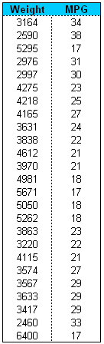
The data can be organized into two columns as in the right table, or we say we have n observations (x₁,y₁) ,…, (x_{n},y_{n}) .

To reveal the possible connection between x and y, we can use the scatterplot.

This scatterplot shows that there is a negative, possibly linear relationship between mpg and weight.

Sample correlation coefficient

Population correlation Cor(X,Y) measures the linear dependency between variables X and Y, once the joint distribution of X and Y is known.

When we only have the data (not the distribution information), we can compute a sample correlation coefficient as a rough estimation for the population correlation. This sample correlation coefficient thus measures the linear dependency of the sample data.

- ;
- r value is invariant to data rescaling.
- r is positive mean positive linear relationship and vice versa;
- r=-1 or 1 if and only if the scatterplot lies exactly on a straight line.
- Absolute value of r measure the strength of linear relationship.

Simple regression model

The relationship between random variable Y and dependent variable x follows

where are independent normal variable .
There are totally three parameters
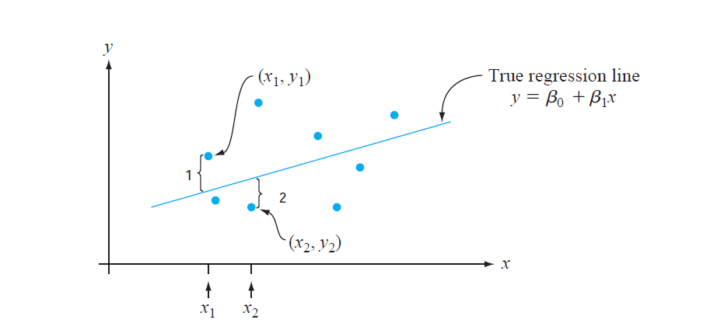

Given x, the conditional distribution of Y follows, or in other words
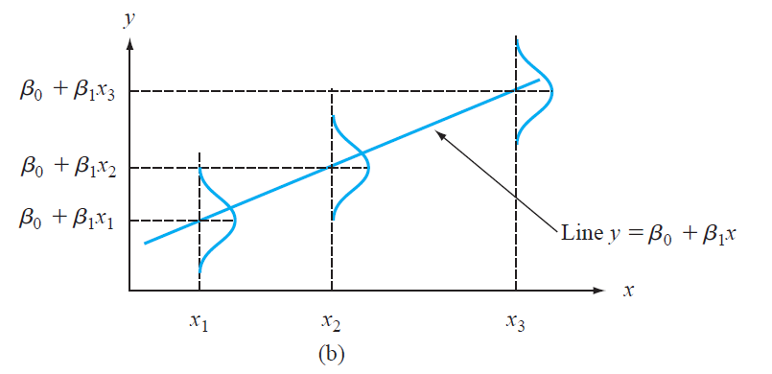

Parameter estimation

Question: how to estimate the three parameters in the simple regression model given the data set?
MLE, Moment estimator are both possible, here we proposed the least square estimator.

The least square estimator finds the straight line which are closest to the data points.

Definition: The least square estimator is defined as

which minimizes the sum of squared error.

The solution of the above optimization is
and

Fitted value:

Residual:
Note:

Prediction given a new x*: the predicted value is
Note: the above prediction should not be used to make a prediction for an x value much beyond the range of the data, “danger of extrapolation”.

SSE: ,

The three estimators listed in above are all UNBIASED estimator.

The coefficient of Determination: how good is a linear regression fit

Definition:
It is interpreted as the proportion of observed y variation that can be explained by the simple linear regression model (attributed to an approximate linear relationship between y and x).

R code:

x<-1:10; y<- x*2+rnorm(10)+0.5

plot(x,y);abline(lm(y~x));

lm(y~x);
lm(y~x)$fitted.value; lm(y~x)$residuals
summary(lm(y~x))
anova(lm(y~x))

Inference about the slope parameter

The estimator is a random variable, whose sampling distribution depends on the random sample. Now we study its sampling distribution, and use it to derive CI or test statistic.

Note that

By the independence of y,

Exercise: derive the sampling distribution of by yourself.

Theorem:

note that is the estimated standard error of
This theorem implies the following CI and HT:

Confidence interval

t-testing for
Test statistics:

Rejection region is:

F-testing for
Test statistics:

Rejection region is:

ANOVA table for single regression:
Source | DF | Sum of Squares | Mean Square | F Ratio | Prob > F
Treatment | 1 | SSR | MSR=SSR/(1) | F=MSR/MSE
Error | N-2 | SSE | MSE=SSE/(N-2)
Total | N-1 | SST

Inference about the prediction

Now we are interested in prediction, that is to predict the possible response when a new observation is given.

1) Given a new x*, we want to estimate

Point estimator: Since both and are unbiased estimator, we have

Confidence interval:
The sampling distribution of is

Therefore,

where is the estimated standard error.

Confidence interval for

One can also derive a Hypothesis testing formula by yourself.

Prediction interval: find an interval such that

In comparison, the previous confidence interval is

Note that, by independence

Therefore, the PI is

R code:

x<-1:10; y<- x*2+rnorm(10)+0.5
m1<-lm(y~x);

predict(m1, newdata=data.frame(x=3.5), interval="confidence", level=.95)

predict(m1, newdata=data.frame(x=3.5), interval="prediction", level=.95)

Model diagnose: residual plot
There are three crucial assumptions of linear regression model.
- Linearity
- Normality
- Equal variance

In practice, we need to make sure these assumption is appropriate for our data.

Residuals plot:
A data point’s residual tells us how much a subject’s response value differs from the average response value.
A plot of the residuals (residuals vs predicted values) tells us about the variation of the data values about the predicted regression line.
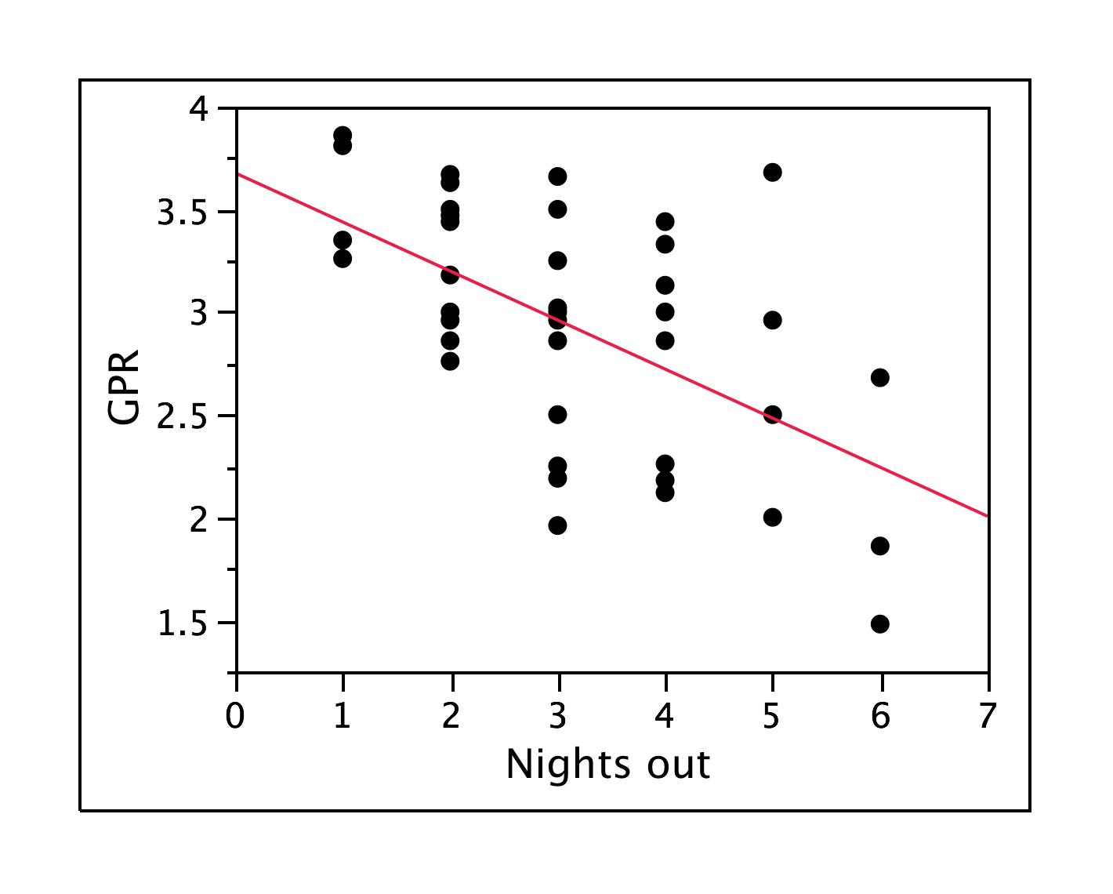

R code : plot(lm(y~x))

How to check model assumptions

- Checking the assumption of a linear relationship between μ_{Y|X} and the value of x.

  - Look at the scatter plot and residual plot and make sure that the pattern of the points looks linear or like a shotgun pattern.

- Checking the assumption that the responses are normally distributed about their means

  - Look at the normal QQ plot of the residuals and make sure you don’t see a “C” shape.

- Checking the assumption of equal variances

  - Look at the scatter plot of residuals, you want to see a horizontal band of points or a shotgun pattern. You do NOT want to see a wedge shape, or clear pattern of trend.

- Also need to check that there are no extreme outliers.

Example where all the conditions are met:

Scatter plot used to check linearity NQ plot to check for normality Residual plot to check
Equal Variances

EXAMPLES WHERE THE MODEL ASSUMPTIONS DON’T HOLD

Data Not linear

In the case above, the explanatory and response are not linearly related but everything else is ok although the lack of linearity messes up the scatter plot of the residuals (plot on far right above).

Data Not normally distributed

Data doesn’t have equal variances

In the example below, the responses for each X value are normal BUT the variances increase as X increases. As a result, the constant variance assumption is violated.

More examples of not equal variances

