Linear Regression

Inferential statistics for 2 numerical variables

Now we want to make statistical inferences a population based on the data when there appears to be a linear relationship between the explanatory variable (numerical) and the response variable (numerical).

EX 1 We are interested in determining if there is statistical evidence of a linear relationship between height and weight in the population. In particular, in the Spring 02 STAT 302 class (population of interest), were taller people, in general heavier? I took a random sample of people in this class. This data is plotted below.

Explanatory variable: height Response variable: weight

The first step in answering this question is to make a scatter plot (see below). It is clear that there is a general positive linear trend and that as height increases, on average, weight also increases. There are no outrageous outliers and the correlation, R = .660, is a good measure of the strength of the linear association.

From this data, I can estimate the equation for the regression line: The line used to estimate the true population line is:

${\hat{μ}}_{Y|X}$= − 247 + 6.0 x

= the estimated average weight of all individuals who are x inches tall.

For example, the estimated average weight of people 70.0
Inches tall is

-247 + 6.070.0 = 173.0 lbs.

Definitions of the parameters of interest

μ_{Y|x} = β₀ + β₁x equation of the population regression line

μ_{Y|x} is the average response value for all individuals in the population defined by the explanatory variable value x. This is a population parameter.

- EX 6: Explanatory variable = height
Response variable = weight.
μ_{Y|64} = average weight of all people in the population who are 64 inches tall.

The slope, β₁ of the regression line measures the change in μ_{Y|x} for every unit change in the explanatory variable x. This is a population parameter.

- EX 6: β₁ = average change in weight when height increased by 1 inch for this population

β₁ is estimated by b₁ = slope of the line which is the best fit through the data.

- Using computer output, the value of b₁ is calculated from the data set. b₁ is a statistic calculated from the data.
b₁ > 0 b₁ < 0 b₁ = 0

The true intercept, β_{0,} of the mean function tells the value of μ_{Y|X} when X = 0. β₀ is a population parameter.

We estimate the value of β₀ with b₀. b₀ is a statistic calculated from the data.

The estimated value of μ_{Y|x} is written . We use the expression b₀ + b₁x = to calculate the value ${\hat{μ}}_{Y|X}$from the values of x, b₁ and b₀.

EX 1 revisited: ${\hat{m}}_{Y|X}$= − 247 + 6.0x b₀ = b₁ = ${\hat{m}}_{Y|\text{70}}$ = -247 + 6.070.0 = 173.0 lbs.
Simple Linear Regression
Statistical Inferences when 2 numerical variables

In linear regression the idea is to test if there is a linear relationship between the explanatory and response variable. The way we tell if there is a linear relationship is to test if the slope of the least squares line is not zero. Of course, this only makes sense when the conditions are met (see pages 6-8).

The 3 possible hypotheses that can be tested using linear regression methods are:

There is a positive linear relationship: H₀: β₁ = 0 vs H_{A}: β₁ > 0 1-sided
There is a negative linear relationship: H₀: β₁ = 0 vs H_{A}: β₁ < 0 1-sided
There is a linear relationship: H₀: β₁ = 0 vs H_{A}: β₁ ≠ 0 2-sided

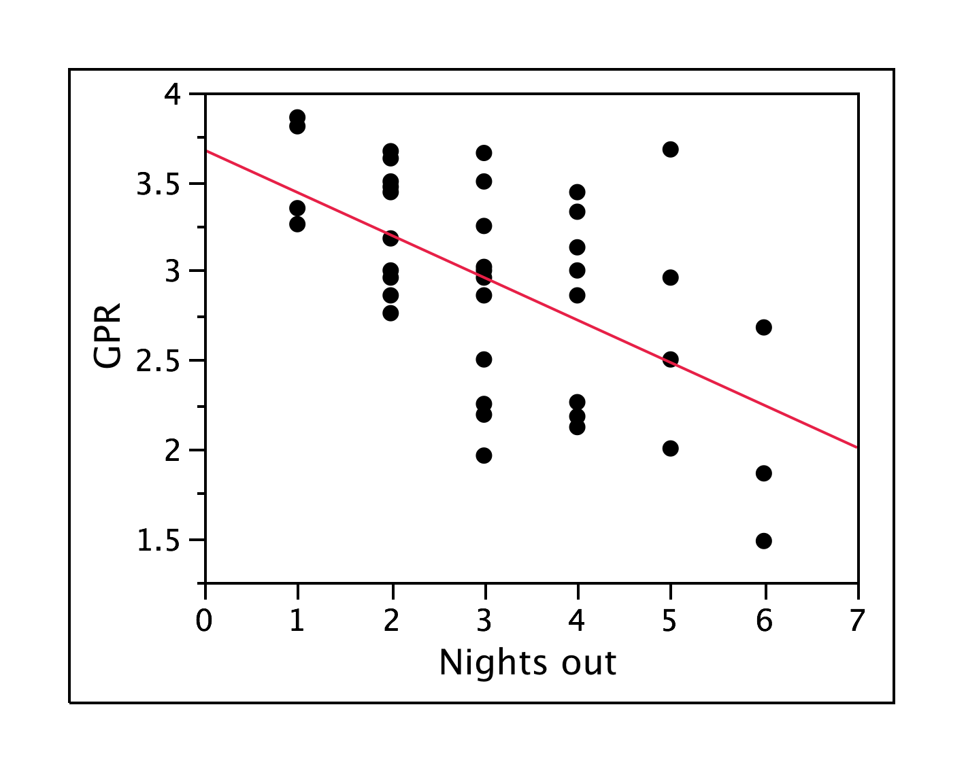
EX 2: Theory: the number of times a TAMU student goes out per week is negatively linearly related to their GPR. A SRS was taken of 43 STAT 302 students in Fall 02. Below is a scatter plot of their data. We want to test this theory at the α = .05 level.

Explanatory variable:

Response variable:

Hypothesis:

 | Multiple | R-Square | Adjusted | Std Err of
Summary | R | R-Square | R-Square | Estimate
 | 0.5722 | 0.3275 | 0.3111 | 0.4831625

Regression | Coefficient | Standard | t-Value | p-Value
Table | Coefficient | Error | t-Value | p-Value
Constant | 3.678 | 0.181 | 20.310 | < 0.0001
# NightsOut | −0.239 | 0.072 | −3.309 | 0.002

b₀ – estimated intercept b₁ – estimated slope p-value for 2-sided hypotheses for β₁

How do we interpret the value of b₁?

- b₁ is a slope estimate which estimates the change in average response when the explanatory variable increases by 1.

- From this data set, we estimate the average GPR drops by 0.24 when the # nights out increases by 1.

Calculating the p-value:

Case 1: You have 2-sided hypotheses: H₀: β₁ = 0 vs H_{A}: β₁ ≠ 0 then JMP gives the correct p-value.

Case 2: You have 1-sided hypotheses
- Data supports H_{A} then the correct p-value = (p-value in table)
    - How to tell if data supports H_{A}.
      - If H_{A}: β₁ > 0 then we must have b₁ > 0.
      - If H_{A}: β₁ < 0 then we must have b₁ < 0.

- You have 1-sided hypotheses and the sign of b₁ doesn’t match H_{A} statement, then FTR H₀.

Regression | Coefficient | Standard | t-Value | p-Value
Table | Coefficient | Error | t-Value | p-Value
Constant | 3.678 | 0.181 | 20.310 | < 0.0001
# NightsOut | −0.239 | 0.072 | −3.309 | 0.002

- What is the correct p-value for testing the hypotheses H₀: β₁ = 0 versus H_{A}: β₁ < 0?

- What is the decision?

- What is the conclusion?

Predicting GPR from # of nights out per week:

- The predicted response of an individual whose explanatory value is x is written as$\hat{y}$. The formula for calculating $\hat{y}$is given by the regression line: $\hat{y}=b_{0}+b_{1}x$

- What is the predicted GPR of a person who goes out 3 times per week?

- Can we predict the GPR of a person who goes out 0 times per week?

As usual, there are conditions that must be met before we can make statistical inferences.

Below is a discussion of those conditions.

We start with defining residuals. These are very important to statisticians but all you need to be able to do is understand enough of the plots to be able to decide if conditions are met.

Residuals:

There are various methods for estimating an equation for the best straight line through a set of data points. The most commonly used method results in a line called the Least Squares Line. The least square line is the line that minimizes the sum of the squared sample residuals.

For a data point with response value , the residual of this data point is:

- A data point’s residual tells us how much a subject’s response value differs from the average response value.

- A plot of the residuals (see lower right) tells us about the variation of the data values about the predicted regression line.

Estimated average GPA = 3.68 − 0.24*nights out

- Estimate the residual for the person who goes out 6 times per week and whose GPR = 1.5.

Assumptions inherent in the model of linear regression:

For theoretical reasons, we divide the target population into many populations according to the explanatory variable value. For example, if x = height and y = weight, then we have a separate population for each height. This assumption is needed because of the mathematical model assumptions we make below. These mathematical assumptions were used when someone devised the hypothesis test for 2 numerical variables. We use these model assumptions to come up with the requirements (conditions) that must be met in order to use a linear regression analysis to analyze our data. If the requirements aren’t met, then we can’t use a linear regression analysis on our data because the results will be nonsense.

For each explanatory variable value, we have a population of y’s. Moreover we have the following 4 conditions:

1. Independence: All the response values are independent. This is assured if the data comes from a random sample and there is exactly 1 response value for each randomly selected subject.

2. Linearity: If individual’s x and y values are linearly related by the equation μ_{Y|x} = β₁x + β₀. The quantity μ_{Y|x} is the average response (average y value) in the population of individuals taking explanatory value x.

3. Normality: For each explanatory variable value x, the response values, y, associated with that x are normally distributed. That means that for each x value, they values (associated with that x value) are normally distributed.

- For example, we expect the weights of everyone who is 70.0 inches tall to be normally distributed.

4. Equal variances: For each explanatory variable value x the response values, y, associated with that x all have the same variance. That means that for each x value, the y values (associated with that x value) all have the same variance, regardless of the x value.

How to check model assumptions

- Checking independence:

  - Make sure there is only 1 response value per subject.

- Checking the assumption of a linear relationship between μ_{Y|X} and the value of x.

  - Look at the scatter plot and make sure that the pattern of the points looks linear or like a shotgun pattern.

- Checking the assumption that the responses are normally distributed about their means

  - Look at the normal QQ plot of the residuals and make sure you don’t see a “C” shape.

- Checking the assumption of equal variances

  - Look at the scatter plot of residuals, you want to see a horizontal band of points or a shotgun pattern. You do NOT want to see a wedge shape.

- Also need to check that there are no extreme outliers as they mess up everything just like with correlation.

Example where all the conditions are met:

Scatter plot used to check linearity NQ plot to check for normality Residual plot to check
Equal Variances

EXAMPLES WHERE THE MODEL ASSUMPTIONS DON’T HOLD
Data Not linear

In the case above, the explanatory and response are not linearly related but everything else is ok although the lack of linearity messes up the scatter plot of the residuals (plot on far right above).

Data Not normally distributed

Data doesn’t have equal variances

In the example below, the responses for each X value are normal BUT the variances increase as X increases. As a result, the constant variance assumption is violated.

More examples of the right side plot used to check equal variances:

Equal variances Not Equal variances

EX 3: Doctors would like a way to predict a premature infant’s weight at birth based on the infant’s gestational age. They wanted to test their theory that gestational age (in weeks) and weight (in grams) are positively linearly related. To test their theory, a researcher group selected a random sample of 100 premature infants and recorded the gestational age at birth and the birth weight of each baby. Assume all conditions are met to do the analysis.
- Explanatory variable:
- Response variable
- Hypotheses:
H₀: β₁ = 0 vs H_{A}: β₁ 0

Are the conditions met to analyze this data set using linear regression?

- Independence: This condition is met because the data comes from a random sample and most importantly, each baby’s response value (birthweight) was only measured once.

- Linear relationship: Yes, visual inspection of the scatter plot shows gestational age at birth and birth weight are linearly related.

- Normality: Condition met, the Q-Q normal plot of the residuals doesn’t have a “C” shape.

- Equal variances: Condition met, the scatter plot of residuals shows a “shotgun” pattern and not a “wedge” pattern.

 | Multiple | R-Square | Adjusted | Std Err of
Summary | R | R-Square | R-Square | Estimate
 | 0.66 | 0.44 | 0.43 | 203.89

Recall the definition of R² from set 2 notes. It is the % of variability in the data’s response values that can be explained by differences in the explanatory values.

- What % of the variability in birth weights in this data set can be explained by differences in gestational age?

Regression | Coeff. | Standard | t-Value | p-Value
Table | Coeff. | Error | t-Value | p-Value
Intercept | -932.40 | 234.49 | -3.976 | 0.0001
gestational age | 70.31 | 22.87 | 3.176 | 0.0010

- How should you interpret the number 70.31 given above?

  - The average birth weight of premature babies increases by approximately 70.3 grams when the gestational age at birth increases by 1 week.

- What is the correct p-value?

- What decision should you make based on the above analysis?

- What is your conclusion?

  - The data provides very strong statistical evidence that for premature babies, gestational age at birth and birth weight are positively linearly related.

Discussion on when we can estimate average response and calculate a predicted response:

Now that we have completed our analysis, we can use the values of the coefficients to form a linear equation relating gestational age and birth weight. Based on this data set we can both estimate the average weight at birth and predict the birth weight of a baby yet to be born after x weeks.

x is the gestational age and$\hat{y}$is the predicted birth weight when the gestational age is x. By looking at the data, I determined that 23 is the minimum age (minimum x value in the data set) and 35 is the maximum age (maximum x value in the data set).

- To find the minimum and maximum value of x, look at the scatter plot of the data.

Therefore, this equation can only be used to estimate average birth weight or predict the weights of infants whose gestational age is between 23 and 35 weeks. It is very important that once a regression is done, the estimates of β₀ and β₁ are only used to estimate averages or predict response values for values of x (gestational age) between the minimum and maximum x values of your data. In other words, we can interpolate between our explanatory data values but we can’t extrapolate to values outside of the range of x values.

Using our equation, we predict that a baby born at 30 weeks will weigh -932.404 + 70.310(30) = 1,176.896 grams at birth.

What is the estimated average weight of babies born at 40 weeks?

