Collecting Data

The purpose of this course is for you to learn what inferences can be made about a population based on information obtained from a sample taken from that population. For inferences to have any validity, the sample must be chosen correctly. How to correctly choose a sample and what can go wrong when a sample is incorrectly chosen is the subject of this chapter.

One common mistake made by people who have not studied statistics is to draw conclusions about a population based on their own experience. We think (without really thinking) that the students at our university are typical. Or we recall an unusual incident that sticks in our memory exactly because it is unusual. We remember an airplane crash that killed several hundred people. We may ignore the fact that data on all flights shows that flying is much safer than driving. We are relying on anecdotes rather than data.
Anecdotal evidence is based on haphazardly selected individual cases, which often come to our attention precisely because they are striking in some way. These cases need not be representative of any larger group of cases.

There are many ways to collect data, such as using available data that was produced in the past for some other purpose but that may help answer a present question. However, the clearest answers to questions often require data produced to answer that specific question. The subject of this chapter is how to design a study and select a sample specifically for the study at hand. We will learn that the study design determines what type of conclusion is possible. This is one of the key of the ideas you’ll learn this semester.

Part 1 – Types of study design

There are two types of study designs:

- Observational studies

  - An observational study observes individuals and measures variables of interest but does not attempt to influence the response. The purpose of an observational study is to describe some group or situation. Observational studies will give us a “picture” of the subjects, disturbed as little as possible by the act of gathering information.

- Experimental studies

  - In an experiment, on the other hand, deliberately imposes some treatment on individuals in order to observe their responses. The purpose of an experiment is to study whether the treatment causes a change in the response.

Experiments are distinguished from observational studies by the active imposition of some treatment on the subjects in the study.
Recent USA Today article. http://www.usatoday.com/money/industries/telecom/2009-09-08-cellphone-radiation-safety_N.htm

Three studies:

1. A German study (Stang et al., 2001) compared 118 patients with a rare form of eye cancer to 475 healthy patients who did not have the eye cancer. The patient’s cell phone use was measured using a questionnaire.

The eye cancer patients used cell phones more often, on the average.

2. A British study (Hepworth et al., 2006) compared 966 patients with brain cancer to 1716 patients who did not have brain cancer. The patient’s cell phone use was measured using a questionnaire. The two groups’ use of cell phones was similar.

3. An Australian study (Repacholi, 1997) conducted an experiment with 200 transgenic mice, specially bred to be susceptible to cancers of the immune system. One hundred mice were exposed for two-half hour periods a day to the same kind of microwaves with roughly the same power as that transmitted from a cell phone. The other 100 were not exposed. After 18 months, the brain tumor rate for the mice exposed to radiation was twice as high as the brain tumor rate for the unexposed mice.

Source: Agresti, A & Franklin C (2009) Statistics: The Art and Science of Learning from Data (2nd edn) Pearson Prentice Hall

References:

Hepworth, SJ et al., (2006) Mobile phone use and risk of glioma in adults: case control study. British Medical
Journal, 332, 883-887.

Repacholi, HM (1997) Radio frequency field exposure and cancer. Environ. Health Prospect, 105, 1565-1568.

Stang A et al., (2001) The possible role of radio frequency radiation in the development of uveal melanoma. Epidemiology, 12(1), 7-12.

How do the three studies differ?

- In studies 1 and 2 no treatments are assigned. Patients are merely questioned. Thus, studies 1 and 2 are observational studies.

- Study 3 uses experiments on mice with the hope of generalizing to humans.

Why do the results of different medical studies sometimes disagree?

- Differing types of studies, data collection, different types of individuals in the study.

- Same basic study design by widely different sample sizes resulting in differences in power.

Could the third study have used human subjects instead?
- No, because it would be unethical to knowingly expose humans to possibly harmful waves

Non-study: A friend who was recently diagnosed with brain cancer was a frequent cell phone user. Is this strong evidence that frequent cell phone use increases the likelihood of getting brain cancer?

Part 2 – Observational Studies
Observational studies rely on samples rather than a census of a population

The population in a statistical study is the entire group of individuals about which we want information

A sample is a part of the population from which we actually collect information or perform an experiment on. We use a sample to draw conclusions about the entire population

A sampling design describes exactly how to choose a sample from the population

The list of individuals from which a sample is actually selected is called the sampling frame.

- Ideally, the sampling frame should list every individual in the population, but in practice this is often difficult.

- A frame that leaves out part of the population is a common source of undercoverage.

Choosing a representative sample from a large and varied population is not so simple.

The first step in a proper sample design is to say exactly what population we want to describe.

The second step is to say exactly what we want to measure—that is, to give exact definitions of our variables.

Example: The CPS contacts about 60,000 households each month. It produces the monthly unemployment rate and various demographics.

One question of interest to the government is the proportion of current U.S. smokers who attempted to quit smoking within the previous 12 months.

The CPS defines its population as all U.S. residents (whether citizens or not) 15 years of age and over who are civilians and are not in an institution such as a prison.

What does it mean to be a “current smoker”? Should we include individuals who smoke only occasionally? What constitutes an “attempt to quit smoking”?

- The CPS defines current smokers as individuals who currently smoke either every day or some days. A quitting attempt is defined as an attempt to quit smoking during the past year that lasted for 24 hours or more.

Good sampling designs called Probability Sampling Designs

Choosing a sample by chance attacks bias by giving all individuals in the sample frame an equal chance to be chosen.

A sample chosen by chance is called a probability sample.

The most common probability sampling designs are simple random sampling, stratified random sampling, and multistage random sampling.

Simple Random Sampling (SRS)

  - A simple random sample of n subjects from a sample frame is any method equivalent to drawing names out of a hat.
  - In a SRS every individual in the sample frame has an equal chance of being selected.
  - The advantage of SRSs are that if the sample frame = population or is very representative of the population, then a SRS will be representative of the population.
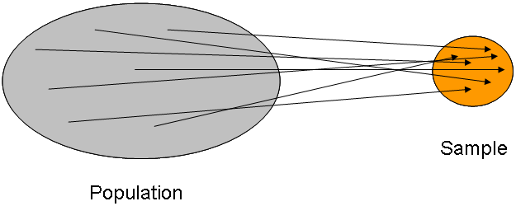

Stratified Sampling

  - A stratified random sample divides the sample frame into separate groups, called strata, and then selects an SRS from each stratum.
  - The strata are frequently the groups defined by the explanatory variable

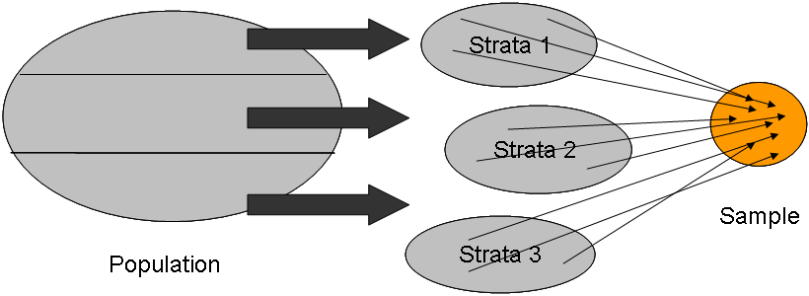

Sample Surveys

A sample survey is an observational study that relies on one or more random samples drawn from a population. By using random sampling, we have a good study using randomness to select the subjects from a sample frame or other unbiased method.

However, problems can still arise even when the subjects for the survey are randomly chosen. Some of these problems are avoidable by the researcher, but most are beyond the researchers control.

The design of a statistical study is biased if it systematically favors certain outcomes.

We will study 3 forms of bias that can arise in sample surveys

- Undercoverage occurs when some groups in the population are left out of the process of choosing the sample; e.g., homeless individuals are left out of surveys that sample households

- Non-response is a particularly serious source of bias in most sample surveys and occurs when a selected individual cannot be contacted or refuses to participate

- Response bias occurs when a subject gives an incorrect response or when the question wording or the way the interviewer asks the questions is confusing or misleading (e.g., “assistance to the poor” versus “welfare”)

The 1936 Literary Digest Poll

The Literary Digest magazine conducted a poll to predict the result of the 1936 Presidential election between Franklin Roosevelt (Democrat and incumbent) and Alf Landon (Republican).

At the time the poll was famous, because they had correctly predicted three successive elections.

In 1936 they mailed questionnaires to 10 million people and asked how they planned to vote. The sampling frame was constructed from telephone directories, country club memberships, and automobile registrations. Only 2.3 million responded.

The Literary Digest predicted that Landon would win, getting 57% of the vote. Instead, Landon got only 36%, and Roosevelt won in a landslide.

What went wrong?

Ideally, the sampling frame should list every individual in the population (i.e., registered voters in the US in 1936). Instead the survey had two severe problems:

Sampling bias due to under coverage: In 1936 the US was in the Great Depression. Those who had cars and country club memberships and thus received questionnaires tend to be relatively wealthy, and tended to vote Republican. In addition, there was no guarantee that an individual in the sampling frame was a registered voter.

Non-response bias: Of the 10 million people who received questionnaires, 7.7 million did not respond. As might be expected, those individuals who were unhappy with the incumbent (Roosevelt) were more likely to complete the questionnaire and return it.

Bad sampling designs

Below are listed some common bad sampling designs resulting in biased samples

Convenience sampling:

A convenience sample chooses individuals close at hand. In a convenience sample, the interviewer makes the choice. Personal choice produces bias. Typically there is no sample frame.

- For example, selecting friends to be part of a study results in a convenience sample. Friends usually have similar characteristics such as being in the same socio-economic group or educational group. Bias results because the subjects are all similar to some extent and don’t represent the population as a whole.

Voluntary response sampling:

A voluntary response sample lets individuals choose whether to participate or not.

- All write-in, call-in, and online polls are examples of voluntary response samples.

- Such samples are biased because people with strong opinions are most likely to respond.

Difference between convenience and voluntary response samples

- In convenience sampling, the researcher selects the subjects. In voluntary response, the researcher sets up the poll but puts it out there for everyone with access (to a computer or website or newspaper) to take the poll. In a voluntary response scenario, the researcher doesn’t pick individuals.

Example 1: Researchers in Hong Kong posted a survey on a popular Hong Kong internet site. In all, 545 Hong Kong residents took the survey. Their responses suggested that close daily monitoring of volatile financial affairs may not be good for your mental health (J. Social and Clinical Psychology 2002; 21:116-28). Subjects who felt that their financial future was out of control had the poorest overall mental health, whereas those who felt control over their financial future had the best mental health.

Example 2: Manufacturers and advertising agencies often use interviews at shopping malls to gather information about the habits of consumers and the effectiveness of ads. A sample of mall shoppers is fast and cheap. “Mall interviewing is being propelled primarily as a budget issue,” one expert told the New York Times. However, mall interviewers tend to select neat, safe-looking individuals from the stream of customers.

Summary of the 5 sources of bias:

Bias possible in a survey of randomly selected people:

In the following cases of bias, the subjects are randomly chosen from a sample frame.

- Under coverage due to use of a poor sample frame that leaves out a subset of the population. Frequently this subset of the population is very hard to contact. Examples of excluded groups include homeless individuals, people in prison, etc.

- Non-response bias: people just choose not to respond. Typically some group is preferentially left off. Typically, males are less likely to participate if polled than females so the results of polls can be skewed towards a more female viewpoint.

- Response bias: This can result from either bad wording in the questions or the responder deciding to lie or not understanding the question due to cultural differences, etc. Bad wording can be used by unscrupulous researchers to get a desired response.

Bias due to bad design:

- Convenience sample: Subjects are not randomly chosen but they are chosen by the researcher because they are convenient for the researcher to study. Typical examples of subjects are family members, friends, co-workers or people the researcher comes into contact with. In these cases there is no sample frame used in selecting subjects in a convenience sample.

- Voluntary response sample: Subjects are not randomly chosen. There is no selection process done by the researcher. The researcher doesn’t choose subjects but instead posts the survey in some public forum and the subjects find the survey and decide to participate. It is true that all subjects in any survey “choose” to participate but in voluntary response, we are referring specifically to people who aren’t selected by the researcher to participate but rather decide to take part in a publically available survey. Typical examples are online polls posted by websites trying to lure you into buying their product or news group websites with an agenda.

Well-designed medical studies - Comparative Observational Studies

Case control studies – retrospective (i.e., the past)

Cross-sectional – single point in time

Cohort studies – prospective (i.e., the future)

Retrospective studies = Case Control Studies:

- In a case-control study, a random sample of individuals with a condition (the cases) is compared with a random sample of individuals without the condition (the controls).

- The controls are chosen from a group of subjects as similar as possible to the case-subjects.

- Researchers study the medical and lifestyle histories of the subjects in each group to learn what factors may be associated with the condition.

- Also called a retrospective study because we are looking “backwards” in time. The goal of case control studies is to determine whether some past difference in circumstances explains why the cases have the condition but the controls don’t.

- Case control studies are a popular approach for rare conditions

- The selection of controls must be done very carefully, or there will be many potential confounding variables

Example: Aflatoxins are toxic compounds secreted by a fungus found in damaged crops. Aflatoxicosis is a rare but very severe poisoning that results from ingestion of aflatoxins in contaminated food. Kenya experienced an outbreak of aflatoxicosis in 2004, resulting in over three hundred cases of liver failure. The Kenya Ministry of Health suspected that improper maize (corn) storage was at least in part responsible for the outbreak.

- Forty case-patients were randomly selected from a list of individuals admitted to a hospital during the 2004 outbreak for unexplained acute jaundice. A preliminary descriptive analysis of the outbreak data suggested that soil, microclimate, and farming practices might be influential factors, but not age or gender.

- Therefore, for each case-patient, the researchers selected at random two individuals from the patient’s village who did not have a history of jaundice symptoms. Selecting individuals living in the same village ensured that the control subjects shared similar soil, microclimate, and farming practices with the case-patients.

- Because age or gender did not appear to matter, the controls were simply randomly selected from the village.

- One conclusion from the case-control study was that improper maize storage was associated with a higher rate of aflatoxicosis but that the amount of maize consumed did not seem to matter.

Cross-sectional studies

A cross-sectional study is one done at a given point in time, and not over the course of time.

In a cross-sectional study, subjects are randomly selected from an appropriate sample frame (subjects come from a cross-section of the society). Various properties are measured on each subject.

For example, a cross-sectional study of a disease such as a specific cancer at one point in time could be undertaken to learn its prevalence and distribution across different groups in the population of interest.

Cross-sectional studies give us a “snap-shot” of what the population looks like “at that particular moment in time”.

Case control studies can’t be used to determine prevalence of a disease because researchers determine how many cases and how many controls are in the study.

Prospective = Cohort studies

Cohort studies (also called Prospective studies) enroll subjects and follow them prospectively over time. (Cohort studies follow people forward in time.)

In a cohort study, subjects sharing a common demographic characteristic (e.g., nurses, UNC alumni) are enrolled and observed at regular intervals over an extended period of time.

Overall, though, cohort studies are less prone to confounding than case-control designs because cohorts start with one homogeneous group. This has other important advantages.

Cohorts can provide information about the relative health risks of different subgroups. They also support incidence calculations (can calculate prevalence of a disease), unlike case-control studies which select subjects based on an existing disease status.

Unlike case-control studies, cohort studies are very costly and better suited to investigating common outcomes such as Type 2 diabetes or heart disease.

Example: The Nurses’ Health Study is one of the largest prospective observational studies designed to examine factors that may affect major chronic diseases in women.

Since 1976 the study has followed a cohort of over 100,000 registered nurses with the idea that nurses would be able to respond accurately to technically worded medical questionnaires.

Every two years, enrolled nurses receive a questionnaire about diseases and health-related topics such as diet and lifestyle. The response rates to the questionnaires are about 90% for each two-year cycle.

In the 2007 newsletter, study investigators reported their findings on age-related memory loss.

About 20,000 women aged 70 and older had completed telephone interviews every two years to assess their memory with a set of cognitive tests.

One of the study findings was that the more women walked during their late 50s and 60s, the better their memory was at age 70 and older.

Although these women were asked to take a cognitive test, the study design was still observational because all women sampled took the test and the investigator did not randomly assign different walking regimens.

Instead, they observed that women who had walked more during their late 50s and 60s ended up with the better memory scores at age 70 and older.

Like all observational studies, cohort designs cannot establish whether observed differences between groups can be attributed to the groups’ differentiating feature or to confounding variables.

What possible confounding variables are there?

  - People who walk must be in good health.

  - People who don’t walk may do so because of other health related issues that affect memory.

Consequently, one confounder is general health.

Because of these confounders, we cannot unambiguously conclude that walking has a protective effect against memory loss.

Advice about observational studies

“Results from observational studies start to become believable when:

- The results are replicated in many studies;
- Each of the studies controlled for possible confounding variables in the statistical analysis.
- There is a plausible scientific explanation for the existence of a causal relationship.”

Source: Wasserman L (2004) All of Statistics: A Concise Course in Statistical Inference. Springer, New York

Key Concept: Association versus causation:

There is an association between two variables if there is some sort of “linkage” between certain explanatory and response variable values.

We frequently want to know if an explanatory variable value causes a particular response.

- Example of causation: Smokers have higher rate of lung cancer than non-smokers because smoking causes changes in the cells in the lungs.

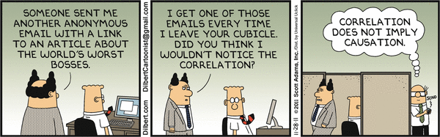

- An observational study, even one based on a statistical sample, is a poor way to gauge the effect of an intervention.

- To determine whether a change in the response is caused by a change in the explanatory variable value, we must actually impose the change.

- When our goal is to understand cause and effect, experiments are the only source of fully convincing data.

- Recall: A lurking variable is a variable that is not among the explanatory or response variables in a study and yet may influence the interpretation of the relationships between those variables.

- Observational studies of the effect of one variable on another often fail because the explanatory variable is confounded with lurking variables. We will see later in this set of notes that well-designed experiments take steps to defeat confounding.

Why experiments control for lurking variables: In experiments, we first randomly divide subjects into treatment groups. If the sample sizes are large enough, then all the treatment groups (before treatment) have approximately the same distribution with respect to all traits like smoking, BMI, exercise habits, etc.

If after treatment, the groups differ in their responses, then the treatment must have caused the response since before treatment the groups were essentially identical. We must also impose certain features on experimental designs in order to claim a cause and effect relationship. Later, we’ll discuss these further.

Example: Wine and Health: Multiple observational studies have been done studying the association between type of alcohol (beer versus wine) and Health.

See: One such study can be found in JC Barefoot et al (2002) Alcoholic beverage preference, diet and health habits in the UNC Alumni Heart Study. American Journal of Clinical Nutrition, 76, 466-472

Explanatory = Response =

These observational studies suggest that drinking wine rather than beer or spirits confers added health benefits.

But people who prefer wine are different ... Moderate wine drinkers as a group are richer and better educated. They eat more fruit and vegetables and less fried food. Their diets contain less fat and less cholesterol. They are less likely to smoke.

The explanatory variable (what type of alcoholic beverage a person drinks most often) is confounded with many lurking variables (such as education, wealth, diet, etc.).

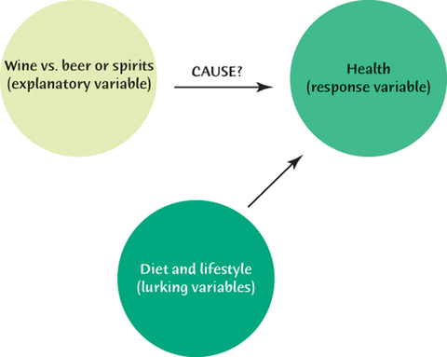

In observational studies, we can’t control for confounding and we can’t eliminate lurking variables because we just observe the subjects and the subjects may group themselves naturally so that there is an association between two explanatory variables which causes the confounding.

The researchers of this large study concluded: “The apparent health benefits of wine compared with other alcoholic beverages, as described by others, may be a result of confounding by dietary habits and other lifestyle factors”. The figure below shows the confounding pictorially.

Part 3 – Experimental Studies

Randomized comparative experiments

- The individuals studied in an experiment are often called subjects, particularly when they are people. Who is studied are also called experimental units.

- The explanatory variables in an experiment are often called factors.

- A treatment is any specific experimental condition applied to the subjects. The treatments are the explanatory variable values.

- Randomization: randomly assigning treatments to subjects.

An experiment that uses both comparison of two or more treatments and chance (or random) assignment of subjects to treatments is a randomized comparative experiment

There are different types of groups within one experiment.

• An experimental group is a group of individuals receiving a treatment whose effect we seek to understand

• A control group is the group of subjects getting a treatment meant to serve as a baseline with which the experimental group is compared.

• A placebo is a control treatment that is fake treatment (for example, taking a sugar pill) but otherwise indistinguishable from the treatment in the experimental group. The “placebo effect” is an improvement in health due not to any treatment but only to the patient’s belief that he or she will improve

EX: Experiment to assess the effectiveness of antidepressants on quitting smoking

To investigate whether it helps smokers to quit smoking if they take antidepressants, one study published in the Annals of Internal Medicine (2001,135; 423-433) used 429 men and women who were 18 or older and had smoked 15 cigarettes or more per day for the previous year. The subjects were highly motivated to quit and in good health.

The subjects were randomly assigned to one of two groups: one group took 300 mg daily of the antidepressant Zyban, the other group did not take Zyban. At the end of the year, the study observed whether each subject had successfully abstained from smoking for a year or had relapsed.

- Experimental units: 429 men and women

- Explanatory variable or treatment: Zyban or not

- Response variable: Whether each subject abstains from smoking for a year

Source: Agresti, A & Franklin C (2009) Statistics: The Art and Science of Learning from Data (2nd ed.) Pearson Prentice Hall

Outcome of the study: About twice as many people who got Zyban were able to quit and stay quit compared to people who took a placebo (fake medicine).

It is possible to have an experiment where subjects are treated but there is only one treatment and no control group or anything else. These experiments could have lurking variables and are badly designed experiments.

EX part a: “Gastric freezing” is a clever treatment for ulcers in the upper intestine. In a study published many years ago, patients with ulcers swallowed a deflated balloon with tubes attached, and then a refrigerated liquid is pumped through the balloon for an hour. The idea is that cooling the stomach will reduce its production of acid and so relieve ulcers. Results from this study showed that about 1/3 of them improved.

What is wrong with this study? How could this experiment be improved?

EX part b: A later experiment randomly divided ulcer patients into two groups. One group was treated by gastric freezing as before. The other group received a placebo treatment in which the liquid in the balloon was at body temperature rather than freezing. The results: 34% of the 83 patients in the treatment group improved, but so did 38% of the 78 patients in the placebo group. This and other properly designed experiments showed that gastric freezing was no better than a placebo, and its use was abandoned.

PSLS Example 8.3 – Example of a good comparative experiment

- Can chocolate help trigger headaches? A study recruited 128 women suffering from chronic headache and assigned them randomly to one of two groups: 64 women ate a chocolate preparation and 64 ate the same preparation made with carob, a natural extract with similar taste but without the caffeine and other psychoactive substances of chocolate.

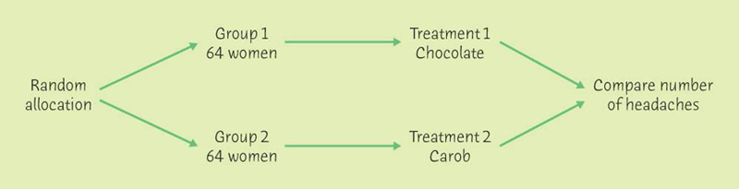

Logic Behind Randomized Comparative Experiments

Randomization ensures that the groups of subjects are similar, on average, in all respects before the treatments are applied. Consequently, randomization breaks the association between the explanatory variable all confounding or lurking variables. This eliminates the possibility of there being confounders because for a variable to be a confounder, it must in the study be associated with the explanatory variable. That is, the explanatory groups must differ according to their confounder variable values. Look back at the Wine vs Beer example on page 4 these notes.

Because the groups of subjects are similar in all respects before the treatments, this means that there will be little difference in the treatment groups’ outcomes unless the treatments themselves actually cause the difference

Principles of experimental design

• Randomize — use impersonal chance to assign subjects to treatments. Randomization ensures that the groups of subjects are similar in all respects before the treatments are applied.

• Control or placebo - control the effects of lurking variables on the response by comparing the effects of two or more treatments and randomly assigning subjects to groups so that the groups are similar in all respects before treatments are applied. If possible, use a placebo (dummy treatment that appears identical to the actual treatment.).

• Use enough subjects in each group to reduce chance variation in the results and to increase power.

• Blinding — In a double-blind experiment, neither the subjects nor the people who interact with them know which treatment each subject is receiving

Double-blinding is obviously necessary whenever the investigator evaluates the experimental outcome. In many medical studies, only the statistician who does the randomization knows which treatment each patient is receiving

Various types of Randomized Comparative Experiments:

- Completely randomized designs

- In a completely randomized experimental design, all the subjects are allocated at random among all the treatments.

- The chocolate experiment on the page before is an example of a completely randomized design

- Matched pairs designs

- A matched pairs design compares exactly two treatments, either by using a series of individuals that are closely matched two by two or by using each individual twice.

- Matched pairs designs require that the assignment of the two treatments within each “pair” be randomized to avoid a systematic bias.

Example: Does nature heal best?

- Differences of electric potential occur naturally from point to point on a body’s skin. Is the natural electric field strength best for helping wounds to heal? If so, changing the field will slow healing.

- Researchers compare the healing rates (in micrometers of skin growth per hour) after a small razor cut is made and either it is left to heal naturally or a change of electric potential is imposed.

- In the matched pairs design all newts received two small razor cuts, one on each forelimb. One limb was left to heal naturally and the other received the electric field disturbance. The side receiving the disturbance was assigned at random, in case healing differed on the right and left sides.

- This design enables one to compare healing rates within a newt, thus removing unexplained variation.

- Block designs

- A block is a group of individuals that are known before the experiment to be similar in some way that is expected to affect the response to the treatments.

- In a block design, the random assignment of individuals to treatments is carried out separately within each block.

PSLS Example 8.7 – Gender differences

- The progress of a type of cancer differs in women and men.

- A clinical experiment to compare three therapies for this cancer therefore treats sex as a blocking variable.

- Two separate randomizations are done, one assigning the female subjects to the treatments and the other assigning the male subjects.

- Note: In blocked designs, subjects go through a 2-step process to get assigned treatment. (1) Subjects assigned to block group and (2) once in a “block group” the treatments are randomly assigned.

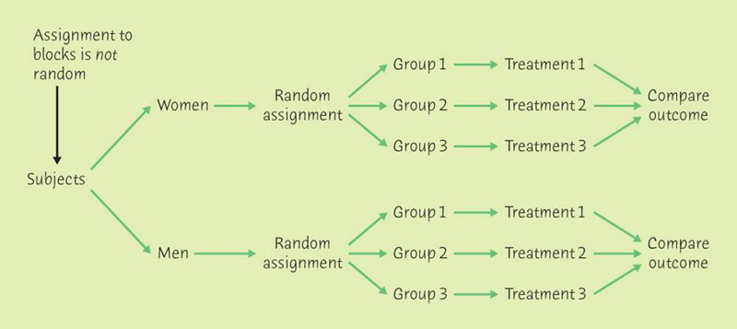

Blocking “controls” for differences in outcome based on gender. We know that frequently men and women have a different response to treatment so by blocking we can compare outcomes within a gender. In general, blocking can decrease the standard deviation in the test statistic resulting in higher power.

Important point about experimentation

- The logic of a randomized comparative experiment depends on our ability to treat all the subjects identically in every way except for the actual treatments being compared.

- All of the subjects in the experiment on the effects of chocolate on headaches received the same medical attention, and they all had tasted both preparations, one containing chocolate and the other carob (the placebo) before the experiment began. The investigators had asked a group of healthy subjects to taste both preparations ahead of time to verify that the two preparations were indistinguishable.

- In addition, the study was double-blind: The subjects didn’t know whether they were taking chocolate or a placebo, and neither did the investigators who gave them the preparation. The double-blind method avoids unconscious bias.

Cautions about experimentation

- Blinding fails when the subjects can tell which treatment they are receiving ( for example, by having pills tested by an external lab)

Ethics of human experimentation

- Are all experiments acceptable in the name of science, knowledge, or the public’s greater good? Both medical ethics and international human rights standards say that “the interests of the subject must always prevail over the interests of science and society.” The quoted words are from the 1964 Helsinki Declaration of the World Medical Association, the most respected international standard.

- Is it morally right to include a placebo in a study design when there are safe and efficient treatments already available? When we don’t know whether the treatment works better than a placebo, it is ethical to try both and compare them.

Summary:

Experimental studies: Researchers impose treatments (assigned at random)

- If an experiment is properly designed and executed and there is statistically significant evidence the different treatments result in different responses, we can conclude statistical evidence of a causal relationship.

- There are 3 different study designs.
- Randomization and blinding are the keys to being able to conclude causality. Randomization implies that 2 or more treatments are being compared.

Observational studies: Researchers observe subjects but do not impose treatments.

- For surveys, must randomly select subjects from a reasonable sample frame in order to be able to generalize results to the general population.
- Three types of general comparative observational studies
- Worry about various forms of bias which skew the results of observational studies.
- Because of the possibility of confounding/lurking variables, we can’t conclude causality.

