Confidence Intervals

Introduction to statistical inference

We will now use what we’ve learned to make statistical inferences about populations of interest.

  - Specifically, in this chapter we will use probability calculations based on the sampling distribution of to estimate the value of the parameter μ to within a margin of error.

  - These calculations are only valid if the data were gathered randomly, by either a random sample or a randomized experiment.

Parameter Estimation

- Parameters of interest we cover in this set of notes

  - The population proportion p
  - The population mean μ

- The only way we can know the exact value of a parameter is to conduct a census.
  - This is often impractical or impossible

- Samples allow us to use a limited set of information to make relatively good guesses about the population’s true parameter value.

Two Types of Parameter Estimates

- Point Estimate

  - A number that is our “best guess” for the parameter.

  - All statistics are point estimates.

- Interval Estimate

  - An interval estimate is a range of plausible values for the parameter.

  - Restated, an interval estimate is an interval of numbers within which the parameter value is believed to fall.

- Example: The birth weight of 10 randomly selected babies is measured. The sample mean of these 10 weights is oz with standard deviation σ = 20.6 oz.

  - 116.9 oz is a point estimate.

  - An interval estimate for μ is the range of values: 104.1 to 129.7 oz.

Reasons why interval estimates are preferred to point estimates:

Properties of Good Point Estimators

- They are unbiased

  - An unbiased estimator has a sampling distribution that is centered at the parameter.

  - In other words, the parameter is the mean of the sampling distribution.

    - unbiased for p
    - unbiased for μ

- They have small standard deviations
.
  - In other words, the standard deviation of the sampling distribution is small.

  - Why is this important?

Bias and Variability

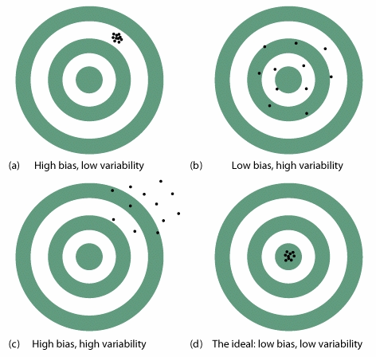

Favorite Interval Estimate: Confidence intervals

All confidence intervals take the basic form:

Point estimate ± margin of error

The point estimate is a sample statistic and always sits in the middle of the confidence interval.

The margin of error represents the accuracy of our guess for the parameter

Confidence level C

The confidence level C determines the percentage of samples whose interval estimate captures the true value of the parameter being estimated.

Restated: The Confidence level C gives the probability of selecting a sample or conducting an experiment which results in data from which the confidence interval we calculate captures the true value of the parameter. That is, the confidence level is the success rate for the method.

  - Sometimes we’ll randomly select a sample in which Point estimate ± margin of error doesn’t capture the parameter of interest. If this would be a very bad thing, then you need to choose a confidence level for which this happens very, very rarely.

The following are true when the confidence level is set at 95% and the parameter of interest is μ, the population mean.

- For 95% of random samples, μ is one of the values in the interval estimate and for 5% it is not.

- If 100 SRS’s were taken from the population and the interval estimate for μ is calculated for each sample, then approximately 95 out of 100 the interval estimates will capture the true value of μ and approximately 5 will not.

- The probability you will randomly select a sample whose confidence interval captures the true value of μ is 95%.

PSLS Figure 14.3: This plot is the result of 25 samples randomly selected from same population. The 95% confidence interval for each sample was calculated and it is plotted below. In the long run, 95% of all samples give an interval that contains the population mean μ.

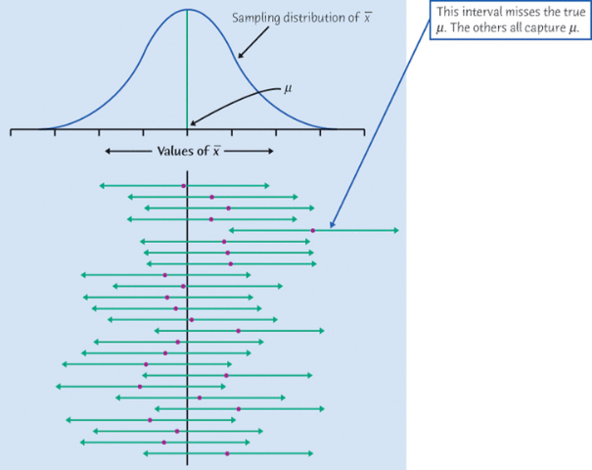

General formula for a 95% confidence interval:

Between and Alternative formulation:

EX 6.1: Human beta-endorphin (HBE) is a hormone secreted by the pituitary gland under conditions of stress. A researcher conducted a study to investigate whether a program of regular exercise might affect the resting (unstressed) concentration of HBE in the blood. Ten adults were subjects in the study. Each subject’s HBE level was measured at the beginning of the study. Then, each subject participated in a 5 month physical fitness program, at the end of which, each subject’s HBE level was measured again. The average drop in HBE level was (pg/mLi) The standard deviation of the change in HBE levels is known to be σ = 12.4 (pg/mLi).

- What parameter are we interested in?

- What is the point estimate of the parameter?

- 95% confidence interval for μ:

- In interval notation this is

- Interpretation: We are 95% confident that, for all adults participating in a 5 month physical fitness program, the average drop in HBE is

Why do we use the word confident?
- ANSWER: Because we used a method that 95% of the time gives an interval that contains μ.

Key Question: Why can’t we interpret our 95% confidence interval as: There is a 95% probability that the average drop in HBE is between 5.3 and 20.7 (pg/mLi) ?

Key point: A confidence interval is an inference about the population based on a calculation using data from a sample.

- A confidence interval only makes an inference about a population parameter. CI’s don’t tell us anything about individuals in the population.

- A confidence interval uses the sample mean in the calculation, but it is not an inference about the sample mean. We know all about the sample because we have data from the data. There is no reason to make inferences about the sample – either the subjects in the sample or statistics calculated from the sample.

Where did the CI formula come from?

For normally distributed random variables, exactly 95.00% of all observations fall within 1.96 standard deviations of the mean.
is a normally distributed random variable with mean and standard deviation
Consequently: 95% of allvalues fall between and

Confidence intervals for μ when σ is known and the sampling distribution is normal

Assume the sampling distribution of normal and σ is known.

Confidence interval (with confidence level C) for the population mean μ:

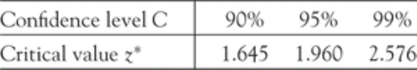
z* is called the critical value

EX 6.2: According to traditional wisdom (deriving from the ancient Greeks), the most “beautiful” human faces are those with proportions that conform to the golden ratio, which is length/width = ≈ 1.618
For Elvis
A = 1.85
B = 1.07
Ratio = A/B = 1.73

Of course, nobody thinks that every single beautiful person will have a facial ratio that is exactly equal to 1.618. This ratio will, of course, vary from person to person. The question is, is it possible that this distribution is centered at the golden ratio (in other words, is the mean ratio μ = 1.618)?

A group of students was interested in estimating the true mean facial ratio for those who are considered “beautiful” for the years 1998 to 2002 by People Magazine. The students randomly select 36 names from a list of all the people named in People’s 50 Most Beautiful People during the years 1998 to 2002. For each of the 36 people, they measured the facial ratios of all those in the sample and found the following

Audrey Tautou | 1.60 |  | Hilary Swank | 1.63 |  | Blaine Trump | 1.50 |  | Chow Yun-Fat | 1.48
Nicole Kidman | 1.61 |  | Emme | 1.37 |  | Denzel Washington | 1.43 |  | Apolo Ohno | 1.61
Bo Derek | 1.57 |  | Dule Hill | 1.47 |  | Ricky Martin | 1.30 |  | Jaclyn Smith | 1.66
Amanda Peet | 1.52 |  | Julia Roberts | 1.54 |  | Goran Visnjic | 1.41 |  | Gwyneth Paltrow | 1.51
Heather Graham | 1.45 |  | Alicia Keys | 1.60 |  | Christina Applegate | 1.44 |  | Sydney Potier | 1.76
Tom Selleck | 1.45 |  | Cameron Diaz | 1.42 |  | Halle Berry | 1.56 |  | Stephan Jenkins | 1.71
Julie Bowen | 1.44 |  | Troy Garity | 1.41 |  | Ashley Judd | 1.61
Olivia Newton-John | 1.46 |  | Jon Grunden | 1.44 |  | Daljit Dhaliwal | 1.36
Henry Simmons | 1.63 |  | Jimmy Fallon | 1.58 |  | Ilia Kulik | 1.59
Hugh Jackman | 1.45 |  | Tom Brokaw | 1.38 |  | Benjamin Bratt | 1.57

- Find a 95% confidence for μ = mean facial ratio of all people listed in People’s 50 Most Beautiful People from 1998 to 2002.
- The sample mean = 1.54 and σ = 0.12.

Interpretation:

- Do you think there is statistical evidence the average facial ratio of beautiful people is not 1.618?

Conditions the data set must meet to be able to use our formulas to calculate CI’s for μ:

Condition 1: The data were collected in such a way that the data values are independence

- Condition 1 is met if the subjects were randomly selected or the data came from a good randomized experiment.

Condition 2: The sampling distribution of is approximately normal

- Rule when n ≥ 30: Condition 2 is met if n ≥ 30 or larger and there are no extreme outliers, then the distribution assumption of normality is assumed to be met.

  - Check the box plot from the data set for extreme outliers. An extreme outlier is any outlier more than 3 box lengths from the edge of the box in the box plot.

- Rule when n < 30: Condition 2 is met if there are no extreme outliers and the data looks approximately normal.
.
  - When n < 30, we look at the box plot, histogram and QQ normal plot from the data set to decide if there are any extreme outliers and if the data appears to be approximately normally distributed.

If both conditions are met, then it is appropriate to use our formula to calculate confidence intervals from our data.

If the data values aren’t independent or we can’t justify condition 2, then we can’t use our formula to calculate confidence intervals from our data because our actual confidence level won’t be what we think it is.

An example of when we can’t justify condition 2 would be if there are extreme outliers or n < 30 and the data isn’t approximately normally distributed.

EX 6.3: The FFQ is a food frequency questionnaire, which uses a carefully designed series of questions to determine the dietary intakes of participants in the study. In the Nurses’ Health Study, a random sample of 166 female nurses each completed the FFQ. The variable being measured is the % fat in the diet.

36.50 and σ = 6.75.

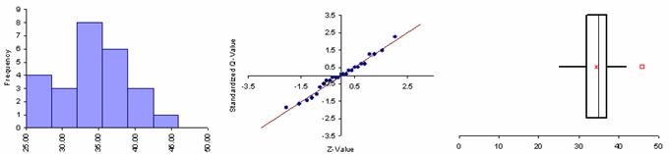

- What is the parameter of interest?

  - ANSWER: The average % fat in the diet of all women similar to the female nurses in this study during the time period that this study was conducted.

- Are the conditions met to calculate a valid confidence interval to estimate this parameter?

Find the following confidence intervals for μ = average% fat in the diet of all women similar to the female nurses in this study during the time period that this study was conducted

- 90% C

- 95% CI

- 99% CI:

- What happens to the margin of error as the confidence level increases?

- What is the correct interpretation of the 99% confidence interval we calculated?

  - ANSWER: We are 99% confident the average % fat in the diet of all women similar to the female nurses in this study during the time period that this study was conducted is between 35.15% and 37.85%.

- Suppose that instead of 166 subjects in the sample, we’d only had 31 subjects? What would our 99% confidence interval be? Assume the sample mean stays the same.
- ANSWER:

- When n = 31 the margin of error equals 3.123 compared to a margin of error of 1.35 when n = 166. Why is the margin of error so much smaller when the sample size is166 compared to when n = 31?

Factors affecting the width of a confidence interval:

- Sample size -

- Confidence level -

Sample size for estimating a population mean using a CI within a particular margin of error

- The margin of error of a confidence interval of the mean μ is:
- Formula: For a margin of error no larger than m, set rounded UP, unless the number you calculated is exactly an integer.

EX 6.3 continued: For the example we just did, what is the minimum sample size needed for a 99% confidence interval to have of margin of error no more than 0.5%?

36.50 and σ = 6.75.

Confidence Intervals for Proportions

To estimate a population proportion p, we use the sample proportion .

If our conditions for inference apply, the sampling distribution ofis close to Normal with mean p and standard deviation $\sqrt{\frac{p(1−p)}{n}}$. But when we are doing inferential statistics (calculating confidence intervals and doing hypothesis testing), we don’t know the value of p, so we will have to estimate the standard deviation of with

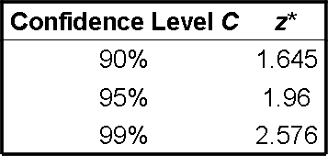
To obtain a level C confidence interval for p, we will use:

Confidence interval formula:

Assumptions for CI to be valid: The following assumptions must be met or the confidence interval won’t capture the true value of the population proportion at the designated confidence level:

- The data values are independent from one another.

  - This will be true if the data came from a SRS.
  - In general, this condition is hard to check for experiments or medical studies.

- The confidence level is what we say it is:

  - This will be true if both and

  - NOTE: This is a different condition than was used for determining whether or not the sampling distribution of $\hat{p}$is approximately normal. Because we don’t know the true value of p and we must use $\hat{p}$instead in our confidence interval calculation, we have stricter requirements. These stricter requirements will assure the confidence level we actually have is C.

Example 6.4: Researchers working on developing new treatments for cancer patients often evaluate the effectiveness of new therapies by reporting the proportion of patients who survive for a specified period of time after completion of the treatment.

A new genetic treatment of 870 patients with a particular type of cancer resulted in 330 patients surviving at least 5 years after treatment.

Estimate the proportion of all patients with the specified type of cancer who will survive at least 5 years after being administered this treatment.

- Are the conditions met?

- Use a 90% confidence interval to estimate the proportion of patients who will survive at least 5 years after receiving the new genetic treatment.

- Interpret this 90% confidence interval:

Summary of the ideas behind Parameter Estimation using interval estimates

- Confidence intervals:

  - A confidence interval is a plausible range of values for the true parameter value.

  - The confidence level is the proportion of samples which give a “correct result”. “Correct result” means the true parameter value is one of the values in the confidence interval.

  - Statistical inference: When we calculate a 95% confidence interval we say “we are 95% confident that (describe the parameter being estimated in the context of the problem) is between ______________ and ________________.”

    - For an example of the correct inferential statement about a population based on a 99% confidence interval calculation see the bottom of page 9.

The reason we say we are “95% confident” is that we used a method that gives correct results 95% of the time.

- The only way we can know the exact value of a parameter is to conduct a census.
  - This is often impractical or impossible

- Samples allow us to use a limited set of information to make informed evidence based inferences about the population’s true parameter value.

